**SPRINT 2 PLAN**

Project Name: Boba Tracker

Team Name: Boba Peeps

**GOALS:**

For this sprint, our team goals are to integrate a database to input and store user data, as well as enable multiple users to access the app independently.

**TASKS**

User story 1: As a user, I want to be able to input how much I spend on each drink. (20 Story Points)

* Create an entry form for entering the drink name, drink cost, and the sugar level in the drink.
  + Time estimate: 4 hours
* Total for user story 1: 4 hours

User story 2: As a user, I want to view my information in a chart. (8 Story Points)

* Create a chart
* Connect to backend data
  + Time estimate: 4

User story 3: As a user, I want to be able to create an account to maintain my privacy through a username and password.

* Create multi-user and password system
  + Time estimate: 4

User story 4: As a user, I want to my data stored securely and independently in a database (13 Story Points)

* Create a database in PostgreSQL
  + Time estimate: 1 hour
* Integrate database into application
  + Time estimate: 3 hours
* Total for user story 4: 5 hours

**TEAM ROLES**

* Jarod Alvarez: Product Owner
* Maggie Lee: Developer
* Johana Martinez: Scrum Master
* Thai Nguyen: Developer
* Chi Huynh: Developer

**INITIAL TASK ASSIGNMENT**

* Jarod Alvarez
  + User story: User Story 4
  + Initial Task: Integrate database into app.
* Maggie Lee
  + User story: User Story 2
  + Initial Task: Create a chart.
* Johana Martinez
  + User story: Unser Story 1
  + Initial Task: Create an entry form for entering drink name, drink cost, and the sugar level in the drink.
* Thai Nguyen
  + User story: User Story 3
  + Initial Task: Create multi-user and password system.
* Chi Huynh
  + User story: User story 2
  + Initial Task: Create chart.

**INITIAL SCRUM BOARD**

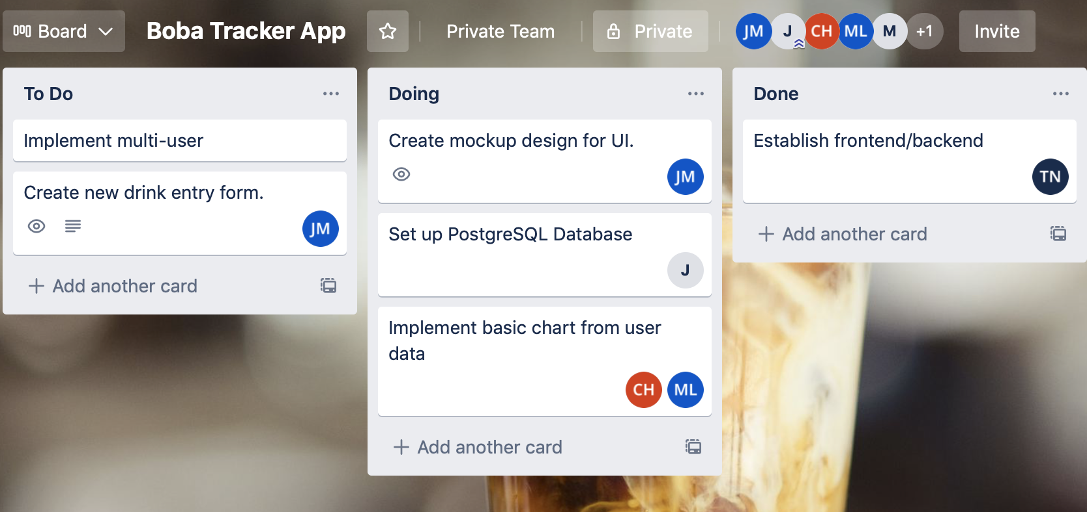

**BURNUP CHART**

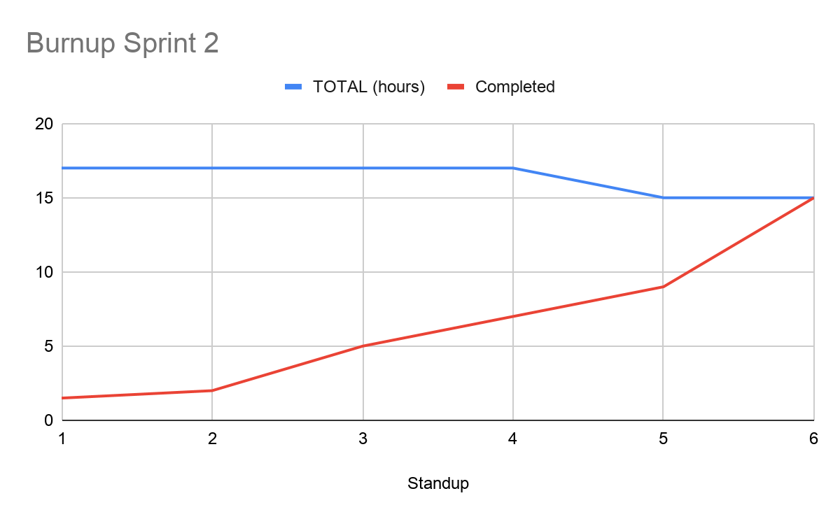

**SCRUM TIMES**

* **MWF - 7pm PST** (Team Stand Up)
* **Thu - 3:30 PST** (Weekly TA Stand Up